**D. Software Design Description**

**1. Design Overview**

This document describes the technical and user interface design of FFRS System. It includes the architectural design, the detailed design of common functions and business functions and the design of database model.

* The architectural design describes the overall architecture of the system and the architecture of each main component and subsystem.
* The detailed design describes static and dynamic structure for each component and functions. It includes class diagram, class explanations and sequence diagrams for each use cases.
* The database design describes the relationships between entities and details of each entity.
* Document overview:
  + Section 2: gives an overall description of the system architecture design.
  + Section 3: gives component diagrams that describes the connection and integration of the system.
  + Section 4: gives the detail design description which includes class diagram, class explanation and sequence diagram to details the application functions.
  + Section 5: describes screen design.
  + Section 6: describes a fully attributed ERD.
  + Section 7: describes algorithms.

**3. Component Diagram**

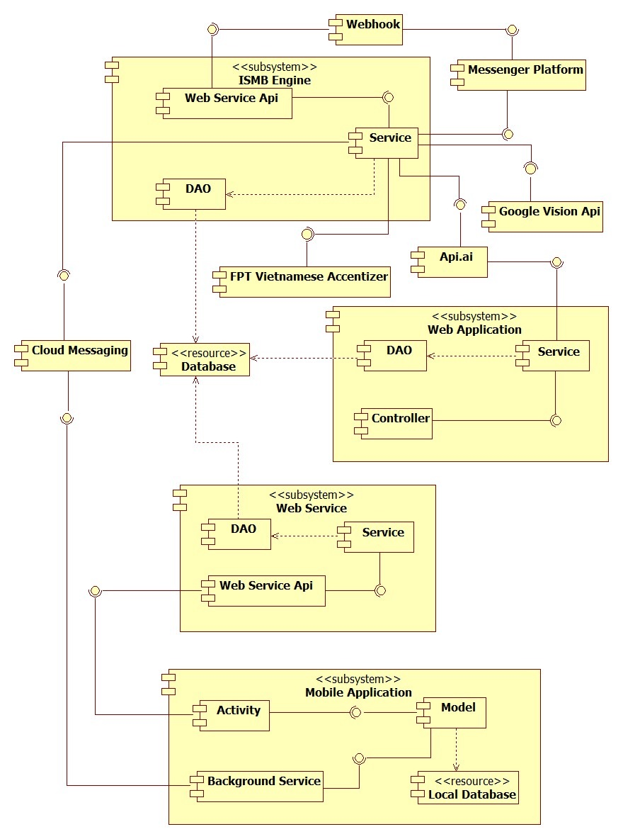

**Figure 57 – Component Diagram**

|  |  |
| --- | --- |
| **Component Dictionary: Describe Components** | |
| **Component Name** | **Description** |
| ISMB Engine | Component handles message from facebook users. |
| Web Application | Component to controll the system and training bot. |
| Web Service | Component provide api for mobile application to interact with the system. |
| Mobile Application | Component handles customers’ activities. |
| Database | Component to store data of the system. |
| Messenger Platform | Component to send message to and receive message from facebook user, provided by Facebook. |
| Webhook | Component handles interactions between Messenger Platform and ISMB Engine. |
| Google Vision Api | Component to detect product in images. |
| FPT Vietnamese Accentizer | Component to add Vietnamese accent into a senetence or phrase (Example: ca phe -> cà phê), provide by FPT. |
| Api.ai | Component to analyze natural language and response prametters that the system need to handle, proviced by Api.ai |
| Cloud Messaging | Coponent sends message from ISMB Engine to Mobile Application. |
| Controller | Component handles request from web. |
| Web Service Api | Component hanldes request from other components. |
| Service | Component handles business logic. |
| DAO | Component that do the interaction between the system and database. |
| Activity | Component handles customers’ interactions. |
| Model | Component handles business logic and interaction with local database. |
| Background Service | Component to run tasks in background. |

**Table 15 - Components Diagram Data Dictionary**

**5. User Interface Design**

**5.2 Mobile Application**

**1. Login**

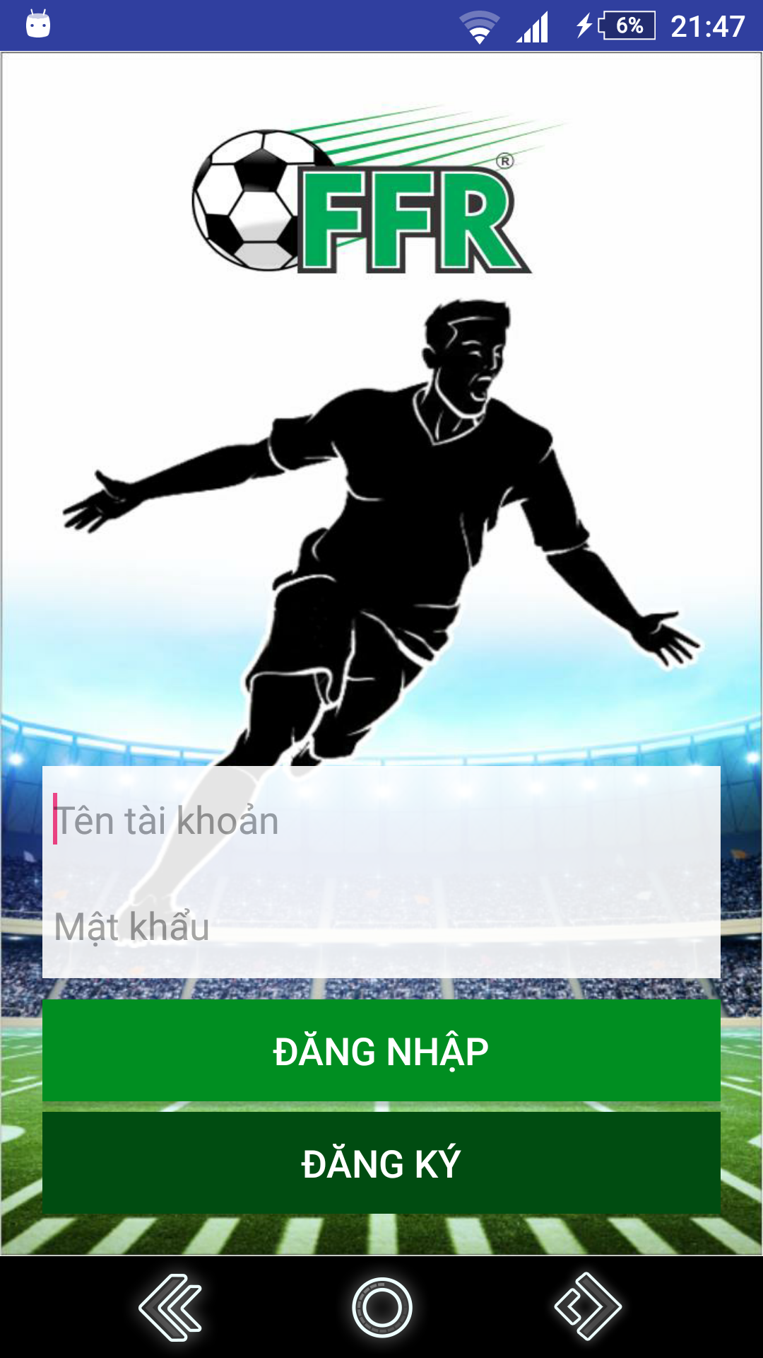

**Figure 99 - Login UI**

**Fields:**

|  |  |  |  |  |  |  |
| --- | --- | --- | --- | --- | --- | --- |
| **No** | **Field Names** | **Description** | **Read Only** | **Mandatory** | **Control Type** | **Data Type** |
| 1 | Username | Fill username | No | Yes | EditText | String |
| 2 | Password | Fill password | No | Yes | EditText | String |

**Table 55 - <Mobile Application> Login Fields**

**Buttons/Hyperlinks**

|  |  |  |  |  |
| --- | --- | --- | --- | --- |
| **No** | **Function** | **Description** | **Validation** | **Outcome** |
| 3 | login | Login with username and password | N/A | Redirect to search field view |
| 4 | register | Create new account | N/A | Redirect to register view |

**Table 56 - <Mobile Application> Login Buttons/Hyperlinks**

**2. Register**

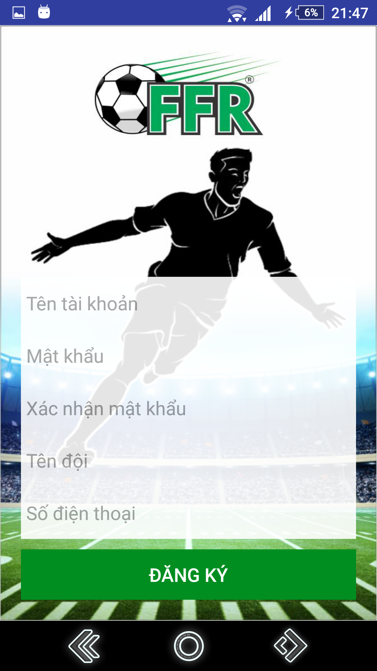

**Figure 100 - Register UI**

**Fields**

|  |  |  |  |  |  |  |
| --- | --- | --- | --- | --- | --- | --- |
| **No** | **Field Names** | **Description** | **Read Only** | **Mandatory** | **Control Type** | **Data Type** |
| 1 | Username | Fill username | No | Yes | EditText | String |
| 2 | Team Name | Fill user’s team name | No | Yes | EditText | String |
| 3 | Phone | Fill phone | No | Yes | EditText | String |

**Table 57 - <Mobile Application> Register Fields**

**Buttons/Hyperlinks**

|  |  |  |  |  |
| --- | --- | --- | --- | --- |
| **No** | **Function** | **Description** | **Validation** | **Outcome** |
| 4 | register | Create new account | All fields required before summit | Redirect to search field view. |

**Table 58 - <Mobile Application> Register Buttons/Hyperlinks**

**3. Menu**

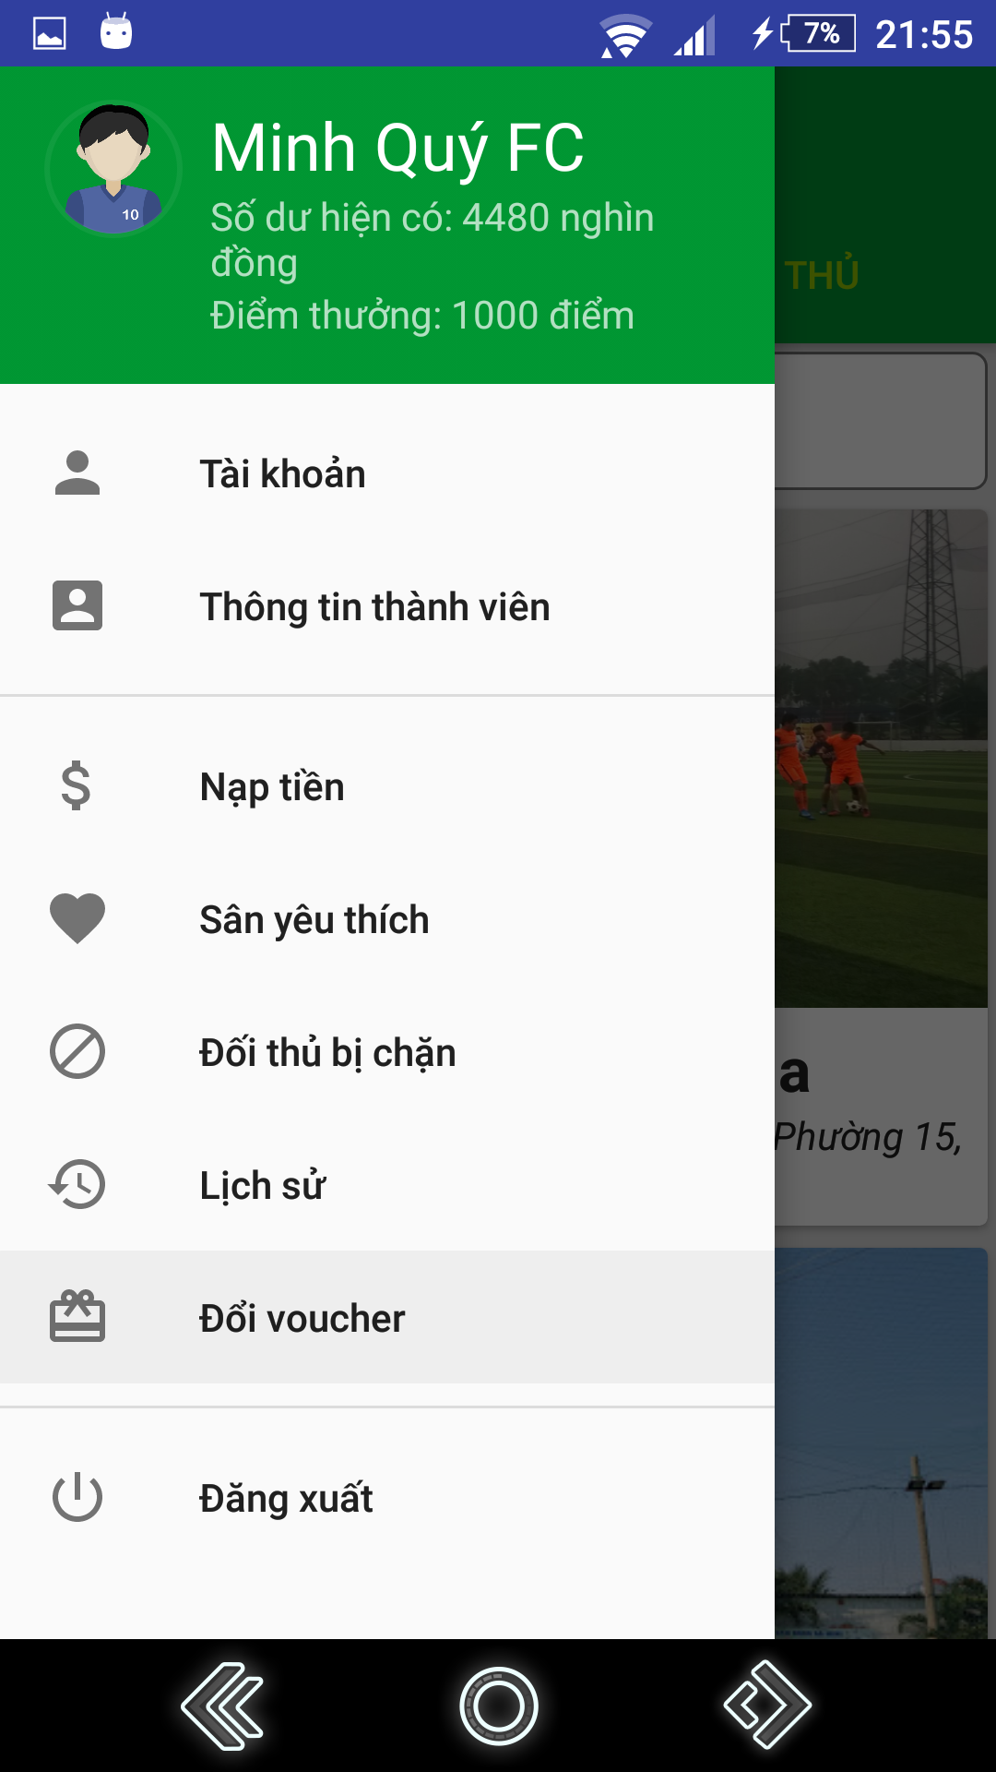

**Figure 101 - Menu UI**

**Fields**

|  |  |  |  |  |  |  |
| --- | --- | --- | --- | --- | --- | --- |
| **No** | **Field Names** | **Description** | **Read Only** | **Mandatory** | **Control Type** | **Data Type** |
| 1 | Name | Name of user | Yes | Yes | TextView | String |
| 2 | Balance | Phone of user | Yes | Yes | TextView | String |
| 3 | Bonus point | Bonus point of user | Yes | Yes | TextView | String |

**Table 59 - <Mobile Application> Menu Fields**

**Buttons/Hyperlinks**

|  |  |  |  |  |
| --- | --- | --- | --- | --- |
| **No** | **Function** | **Description** | **Validation** | **Outcome** |
| 3 | ViewCart | View products in cart | N/A | Redirect to view cart view. |
| 4 | ChangePhone | Change phone number | N/A | Show popup to enter new phone number. |
| 5 | ViewLocation | Show current area of user | N/A | Redirect to view location view. |
| 6 | Logout | Logout of system | N/A | Redirect to login view. |

**Table 60 - <Mobile Application> Menu Buttons/Hyperlinks**

**4. Search Field**

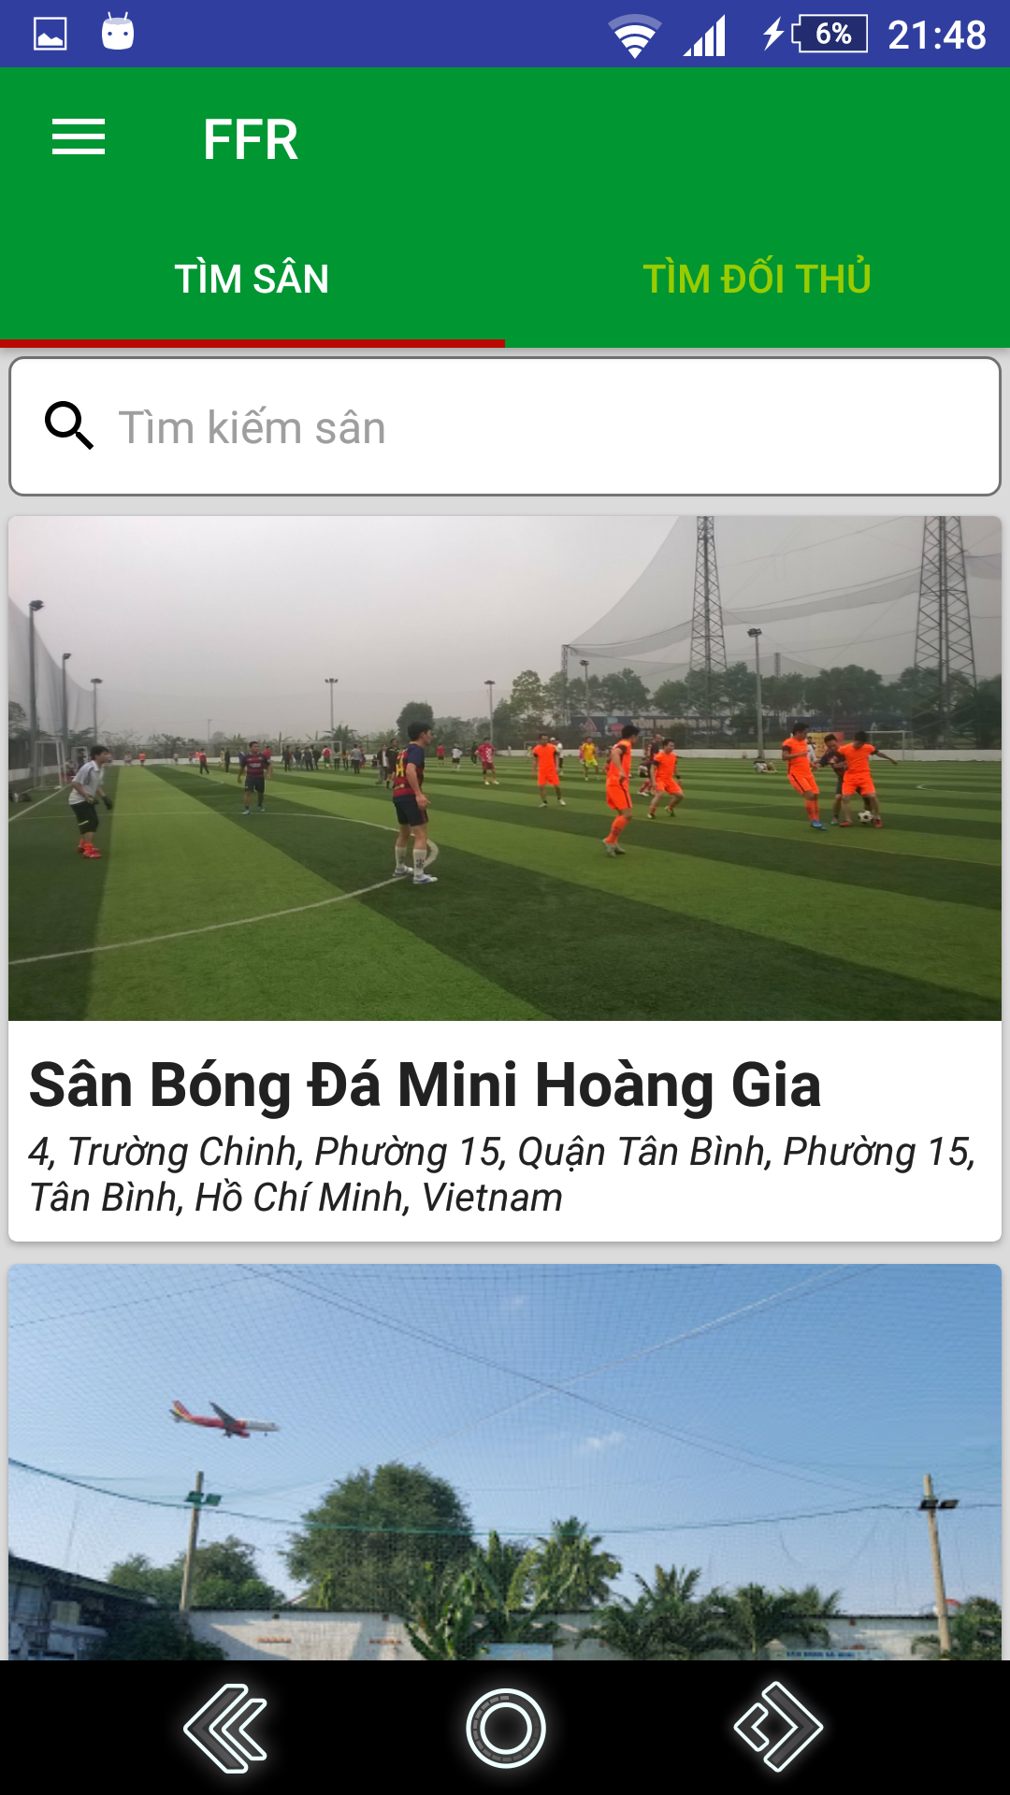

**Figure 102 – Search Field UI**

**Fields**

|  |  |  |  |  |  |  |
| --- | --- | --- | --- | --- | --- | --- |
| **No** | **Field Names** | **Description** | **Read Only** | **Mandatory** | **Control Type** | **Data Type** |
| 2 | fieldName | Field’s name | Yes | No | TextView | String |
| 3 | address | Address | Yes | No | TextView | String |
| 4 | image | Field’s image | Yes | No | ImageView | N/A |

**Table 61 - <Mobile Application> Search Field’s Fields**

**Buttons/Hyperlinks**

|  |  |  |  |  |
| --- | --- | --- | --- | --- |
| **No** | **Function** | **Description** | **Validation** | **Outcome** |
| 1 | showNavigation | Show navigation view | N/A | Show navigation bar |

**Table 62 -<Mobile Application> Search Field Buttons/Hyperlinks**

**Choose field’s free time**

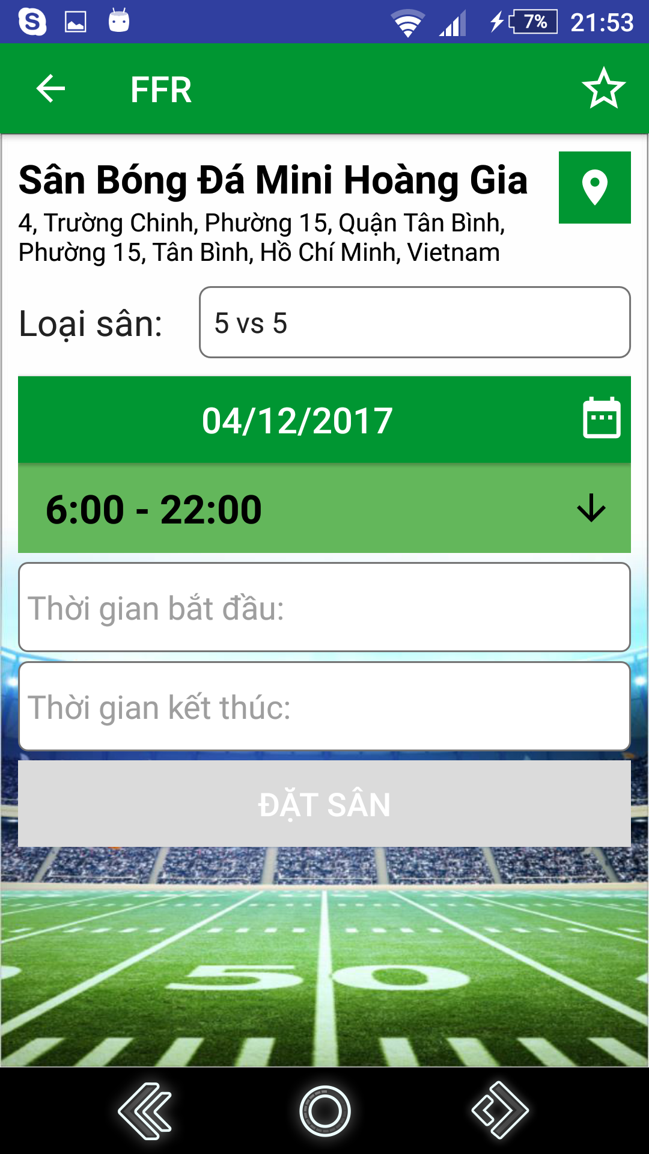

**Figure 103 - Change Phone Number UI**

**Fields**

|  |  |  |  |  |  |  |
| --- | --- | --- | --- | --- | --- | --- |
| **No** | **Field Names** | **Description** | **Read Only** | **Mandatory** | **Control Type** | **Data Type** |
| 1 | PhoneNumber | Fill phone number | No | Yes | EditText | String |

**Table 63 - <Web Application for Customer> Change Phone Number Fields**

**Buttons/Hyperlinks**

|  |  |  |  |  |
| --- | --- | --- | --- | --- |
| **No** | **Function** | **Description** | **Validation** | **Outcome** |
| 2 | updatePhone | Update phone number | All fields required before summit | Redirect to view produce cart page |

**Table 64 - <Web Application for Customer> Change Phone Number Buttons/Hyperlinks**

**View Location**

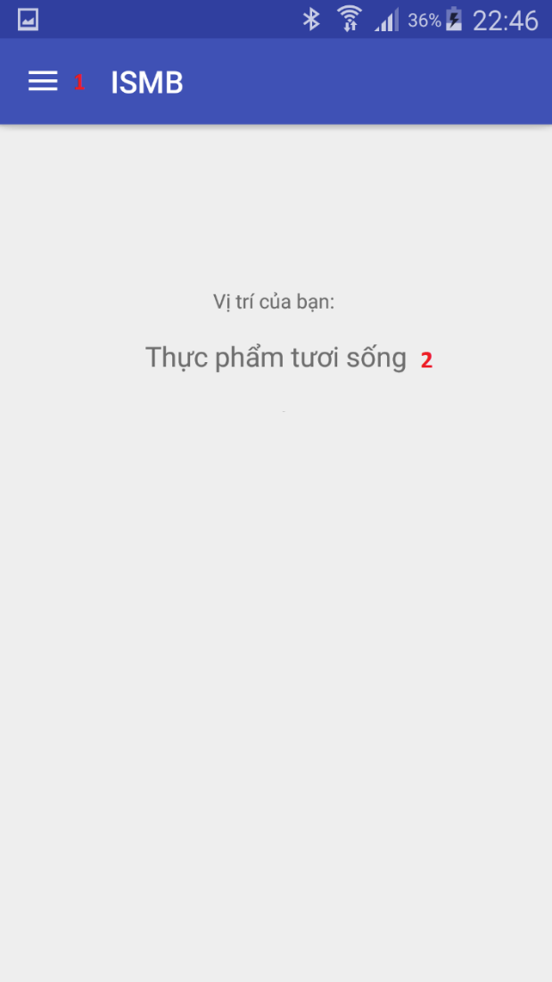

**Figure 104 - View Location UI**

**Fields**

|  |  |  |  |  |  |  |
| --- | --- | --- | --- | --- | --- | --- |
| **No** | **Field Names** | **Description** | **Read Only** | **Mandatory** | **Control Type** | **Data Type** |
| 2 | AreaName | Name of area | Yes | No | TextView | String |

**Table 65 - <Mobile Application for Customer> View Location Fields**

**Buttons/Hyperlinks**

|  |  |  |  |  |
| --- | --- | --- | --- | --- |
| **No** | **Function** | **Description** | **Validation** | **Outcome** |
| 1 | showNavigation | Show navigation view | N/A | Show navigation view |

**Table 66 - <Mobile Application for Customer> View Location Buttons/Hyperlinks**

**Notify Nearby Product**

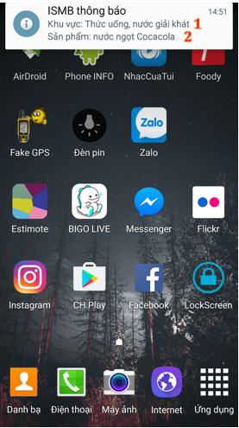

**Figure 105 - Notify Nearby Product UI**

**Fields**

|  |  |  |  |  |  |  |
| --- | --- | --- | --- | --- | --- | --- |
| **No** | **Field Names** | **Description** | **Read Only** | **Mandatory** | **Control Type** | **Data Type** |
| 1 | AreaName | Name of area | Yes | No | Text | String |
| 2 | ProductName | Name of Product | Yes | No | Text | String |

**Table 67 - <Mobile Application for Customer> Notify Nearby Product Fields**

**Buttons/Hyperlinks:** N/A